DIGITAL YACHT LAUNCH NEW AQUA PC RANGE
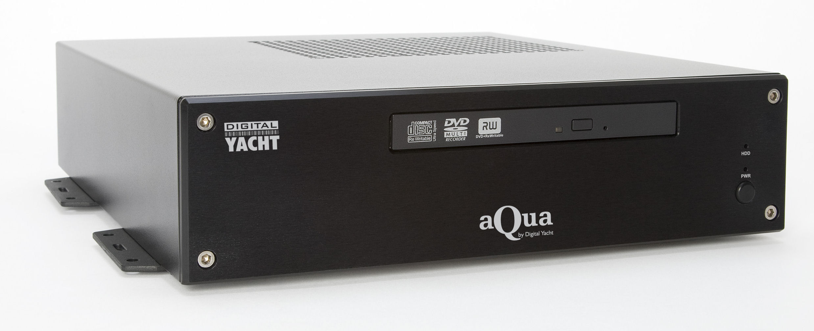
Digital Yacht have launched their new Aqua range of ruggedized marine PCs. The range takes advantage of the latest Windows 7 operating system and incorporates Intel’s Atom processor for ultra low power consumption as well as fast computing. All models run directly from the boat’s DC battery power with a wide ranging 6-30v dc regulator built in, so there is no need for expensive and power hungry inverters. The Aqua processor measures just 30 x 27 x 7cm and can be remotely mounted if required. It comes with a mounting bracket arrangement allowing bulkhead or table top mounting.
The Aqua range is customisable but Digital Yacht recommend three specific configurations which will suit the majority of requirements. The Standard Aqua PC features the ultra low power Atom N270 processor, 80GB Hard Drive, 1GB of RAM, CDRW/DVD drive and two NMEA in/out ports. It is an ideal platform, both in terms of performance, low power consumption and value for money, for customers who wish to have a dedicated and marinised PC onboard for e-mail, web browsing and office type applications.
The AquaNav version has everything the standard Aqua PC has, but adds a sensitive dual channel AIS receiver and 12 channel GPS sensor in addition to the two NMEA ports allowing even greater system integration. It’s specifically designed for use as a navigation device and is compatible with all leading marine charting software packages. AquaNav comes with 2GB RAM and utilises a 32GB solid state hard drive with no mechanical parts for the ultimate in reliability.
AquaMedia is designed as an entertainment device with built in digital TV tuner, BlueRay DVD drive and software for HD movie playback plus it takes advantage of the media capabilities on Windows 7 such as recording and playback of live TV. It uses the dual core Atom 330 processor with enhanced graphics and comes with a huge 250GB rugged drive and 4GB RAM. It also supports both stereo and surround sound audio playback and has dual monitor support - allowing it to drive a chart table VGA screen as well as a high definition entertainment LCD display or plasma in the saloon.
Digital Yacht’s high power Wi-Fi systems can also be included for long range Wi-Fi access to the internet.
The Aqua PC range starts from just £608.65 plus VAT for the standard system.
AquaNav & AquaMedia are priced at £899.00 plus VAT.
Further details are available at www.digitalyacht.co.uk
- ENDS -

Notes for editors:
Digital Yacht
Established in 2001, Digital Yacht is a specialist manufacturer of marine navigation and communication equipment. Our product range includes marine PCs and monitors, TOUCH Navigation System, AIS receivers and transponders, high power Wi-Fi, instrumentation, autopilots and equipment mounting solutions.
Digital Yacht products are available through a network of marine electronic specialist dealers, distributors and installers throughout the world.

For further information, please contact:
Digital Yacht Ltd., Digital House, Unit 10 City Business Park, Easton Road, Bristol, BS5 OSP, UK.
Telephone: +44 (0)1179 554474
Email: sales@digitalyacht.co.uk
www.digitalyacht.co.uk

For further press information, please contact:
Tina Mansell at The Mansell Agency
Telephone: +44 (0)1202 701705. Mobile: +44 (0)7973 850012
Email: tina@themansellagency.com
www.themansellagency.com

